MicroCODE Electronic Notebook

Notebook of: <Your Name>

Month: Month 2025

Document1

Date: Month 1, 2025, day ( )

TASKs…

MEETINGs…

INTERRUPTIONs…

NOTEs…

Date: Month 2, 2025, day ( )

TASKs…

MEETINGs…

INTERRUPTIONs…

NOTEs…

Date: Month 3, 2025, day ( )

TASKs…

MEETINGs…

INTERRUPTIONs…

NOTEs…

Date: Month 4, 2025, day ( )

TASKs…

MEETINGs…

INTERRUPTIONs…

NOTEs…

Date: Month 5, 2025, day ( )

TASKs…

MEETINGs…

INTERRUPTIONs…

NOTEs…

Date: Month 6, 2025, day ( )

TASKs…

MEETINGs…

INTERRUPTIONs…

NOTEs…

Date: Month 7, 2025, day ( )

TASKs…

MEETINGs…

INTERRUPTIONs…

NOTEs…

Date: Month 8, 2025, day ( )

TASKs…

MEETINGs…

INTERRUPTIONs…

NOTEs…

Date: Month 9, 2025, day ( )

TASKs…

MEETINGs…

INTERRUPTIONs…

NOTEs…

Date: Month 10, 2025, day ( )

TASKs…

MEETINGs…

INTERRUPTIONs…

NOTEs…

Date: Month 11, 2025, day ( )

TASKs…

MEETINGs…

INTERRUPTIONs…

NOTEs…

Date: Month 12, 2025, day ( )

TASKs…

MEETINGs…

INTERRUPTIONs…

NOTEs…

Date: Month 13, 2025, day ( )

TASKs…

MEETINGs…

INTERRUPTIONs…

NOTEs…

Date: Month 14, 2025, day ( )

TASKs…

MEETINGs…

INTERRUPTIONs…

NOTEs…

Date: Month 15, 2025, day ( )

TASKs…

MEETINGs…

INTERRUPTIONs…

NOTEs…

Date: Month 16, 2025, day ( )

TASKs…

MEETINGs…

INTERRUPTIONs…

NOTEs…

Date: Month 17, 2025, day ( )

TASKs…

MEETINGs…

INTERRUPTIONs…

NOTEs…

Date: Month 18, 2025, day ( )

TASKs…

MEETINGs…

INTERRUPTIONs…

NOTEs…

Date: Month 19, 2025, day ( )

TASKs…

MEETINGs…

MEETINGs…

INTERRUPTIONs…

NOTEs…

Date: Month 20, 2025, day ( )

TASKs…

MEETINGs…

INTERRUPTIONs…

NOTEs…

Date: Month 21, 2025, day ( )

TASKs…

MEETINGs…

INTERRUPTIONs…

NOTEs…

Date: Month 22, 2025, day ( )

TASKs…

MEETINGs…

INTERRUPTIONs…

NOTEs…

Date: Month 23, 2025, day ( )

TASKs…

MEETINGs…

INTERRUPTIONs…

NOTEs…

Date: Month 24, 2025, day ( )

TASKs…

MEETINGs…

INTERRUPTIONs…

NOTEs…

Date: Month 25, 2025, day ( )

TASKs…

MEETINGs…

INTERRUPTIONs…

NOTEs…

Date: Month 26, 2025, day ( )

TASKs…

MEETINGs…

INTERRUPTIONs…

NOTEs…

Date: Month 27, 2025, day ( )

TASKs…

MEETINGs…

INTERRUPTIONs…

NOTEs…

Date: Month 28, 2025, day ( )

TASKs…

MEETINGs…

INTERRUPTIONs…

NOTEs…

Date: Month 29, 2025, day ( )

TASKs…

MEETINGs…

INTERRUPTIONs…

NOTEs…

Date: Month 30, 2025, day ( )

TASKs…

MEETINGs…

INTERRUPTIONs…

NOTEs…

Date: Month 31, 2025, day ( )

TASKs…

MEETINGs…

INTERRUPTIONs…

NOTEs…

Notebook Templates and Commands

The macros on the next page are available thru the included Normal.dotm.

Replace your existing file with the included Normal.dotm in...

C:\Documents and Settings\<Your Name>\Application Data\Microsoft\Templates

The key chords are mapping with:

Right-Click Command Ribbon and ‘Customize’…

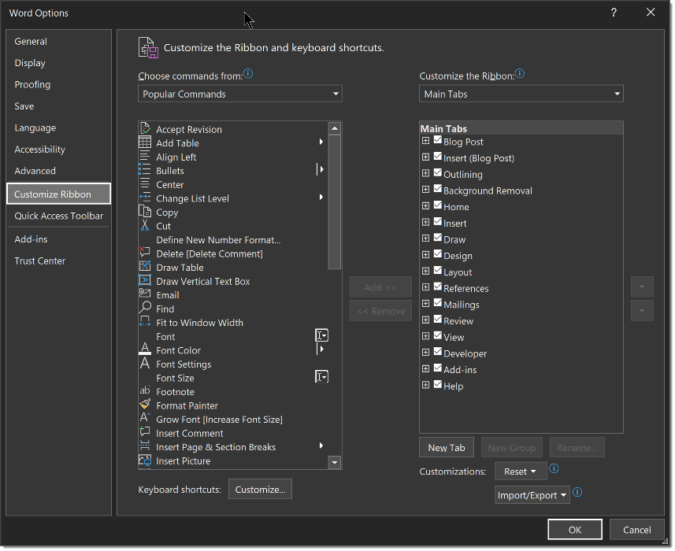

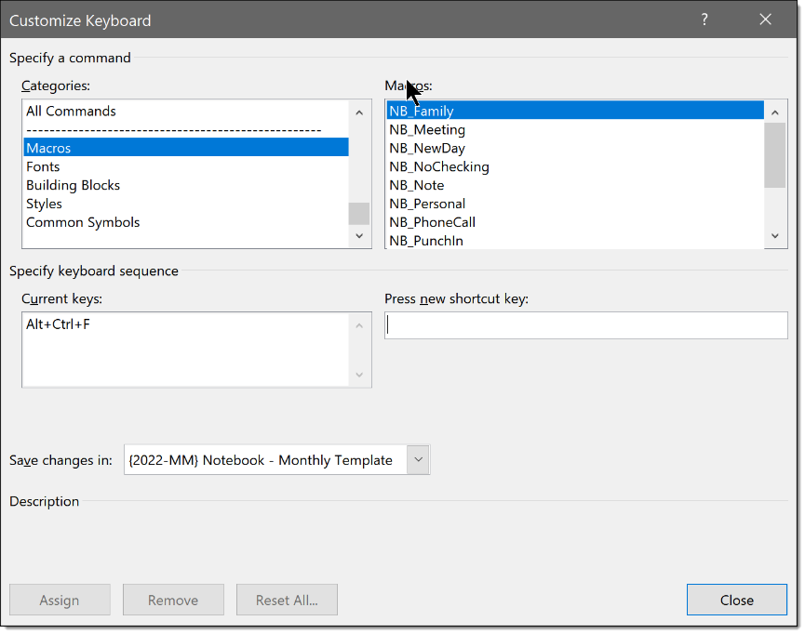

Date: MMMM DD, YYYY, Day-Of-Week (LOCATION)

Start Time: [00:00:00 AM 04-Jan-2014] (Ctrl-Alt-K) ‘START NEW DAY – TIME STARTED’

TASKs…

MEETINGs…

INTERRUPTIONs…

NOTEs…

Start Time: [00:00:00 AM 04-Jan-2014] (Ctrl-Alt-I) ‘IN – TIME STARTED’

Task: [00:00 AM 04-Jan-2014] Description... (Ctrl-Alt-T) ‘TASK’
Task: [00:00 AM 04-Jan-2014] Description...Double-Click Highlight YELLOW = IN PROCESS
Task: [00:00 AM 04-Jan-2014] Description...Double-Click Highlight GREEN = COMPLETED
Task: [00:00 AM 04-Jan-2014] Description... Double-Click Highlight GREY = CARRIED FORWARD

Support: [00:00 AM 04-Jan-2014] Description... (Ctrl-Alt-S) ‘SUPPORT CALL’

Note: [00:00 AM 04-Jan-2014] Description... (Ctrl-Alt-N) ‘NOTE – GENERAL’

Family: [00:00 AM 04-Jan-2014] Description... (Ctrl-Alt-F) ‘PERSONAL BUSINESS’

Meeting: [00:00 AM 04-Jan-2014] Description... (Ctrl-Alt-M) ‘MEETING MINUTES’

Stop Time: [00:00:00 PM 04-Jan-2014] (Ctrl-Alt-O) ‘OUT – TIME STOPPED’

Visual Studio Code line movement…

Alt-Up-Arrow – Move selected line(s) UP one line.
Alt-Down-Arrow – Move selected lines(s) DOWN one line.

